BAP- COMMON TECHNICAL
ISSUES, QUERIES AND ANSWERS

_____________________________________________

User needs to confirm to have the below pre-requisites:

Pre-requisites
The below mentioned hardware and software infrastructure is needed to access the portal and its features:

Field | Description
Hardware - Personal Computer / Laptop
Processor |  | Intel processors Pentium 4 / i3 / i5 / i7 @ 1GHz or above
RAM |  | 1 GB RAM or above (min 1GB recommended)
Hard Disk |  | 80 GB or above HDD
Ethernet Card |  | 10 / 100 Mbps Ethernet card
Printer |  | Laser Jet
Software
Operating System | Windows XP (with Service Pack2), Windows Vista, Windows 7, Mac OS v 10.5
Office Utility | MS- Office 2003 or above
Browsers | Internet Explorer 8.0 / 9.0(in compatibility mode), Apple Safari 5.0 (recommended IE 8.0)
Java Runtime | JRE 1.7  http://www.oracle.com/technetwork/java/javase/downloads/jre7-downloads-1880261.html (Download from this link)
Adobe Acrobat Reader | 9.0 version

Above details are also present in user Manual which can be accessed through below steps:
- Login to BAP (URL : www.irdabap.org.in)
- Click on ‘Help’ tab, User manual will be opened.
- Click on link ‘Pre-requisites’.
Please let us know in case of further assistance required.
--------------------------------------------------------------------------------
Java applet error:
Please confirm the following settings:
Go to Control Panel -> type java in search window
Java icon will be displayed
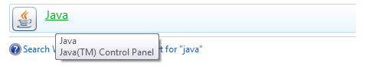

Right click on it and Open properties
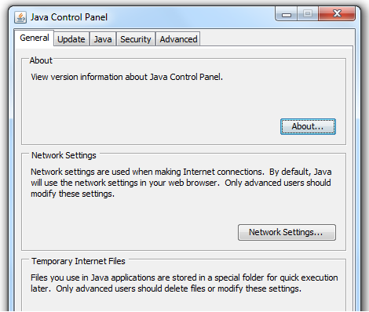

Select Security tab and set Security level to Lowest
Also, lower the security level of IE, steps are as below:
- Go to tools and select Internet option:
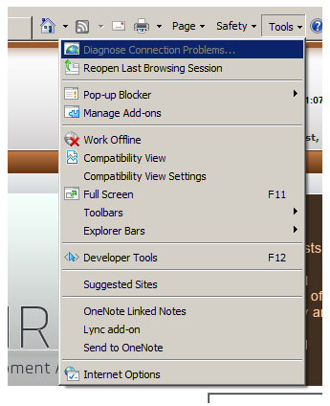

- Select security and scroll down the security level to Low.

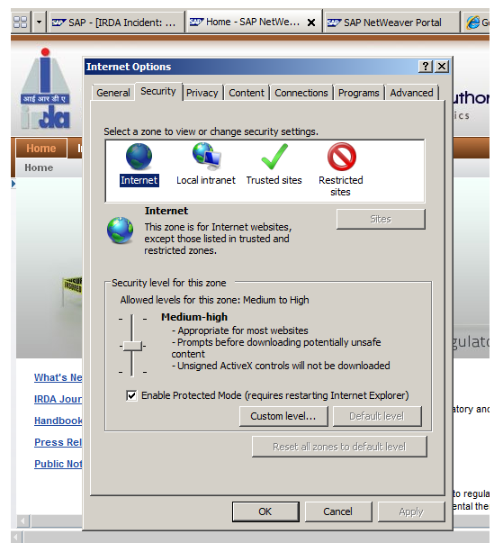

Portal is displaying under construction error:
First go to command prompt and try to ping irdabap.org.in the link mentioned in url.
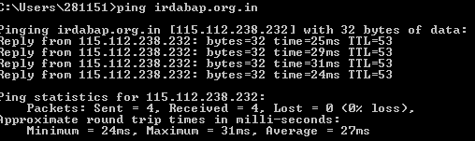

Check the proxy setting in IE, keep its same like other machine where its working fine
-------------------------------------------------------------------------------
Java runtime settings:
JRE 1.7
MS IE 8 only
Go to – Control Panel -> Java -> open properties
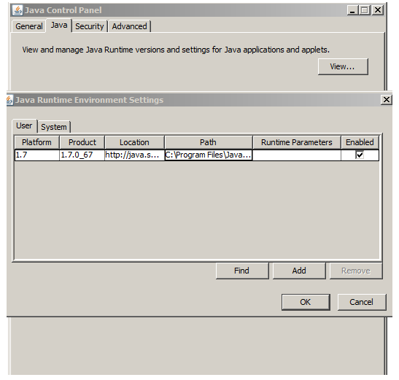

Internet Explorer settings:
MS IE 8
Select Internet Options -> Tools -> Security -> Custom Level

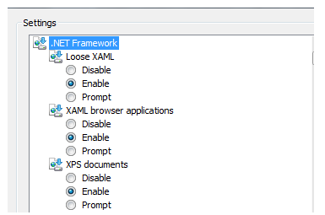

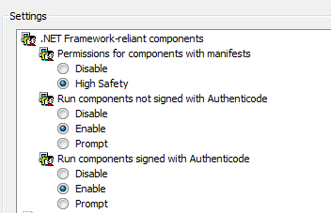

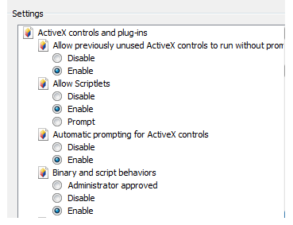

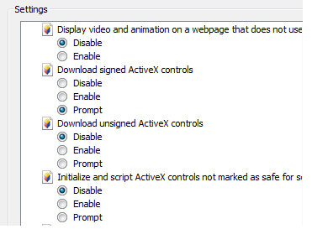

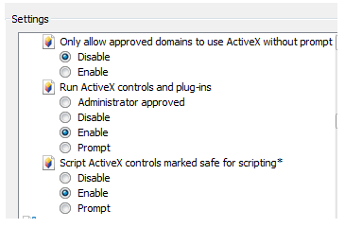

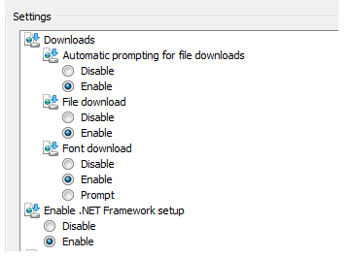

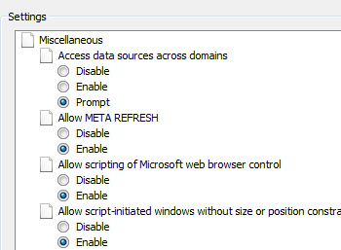

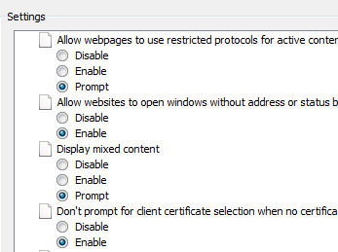

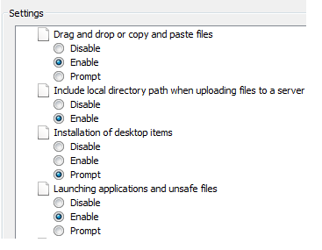

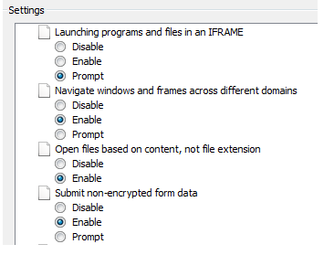

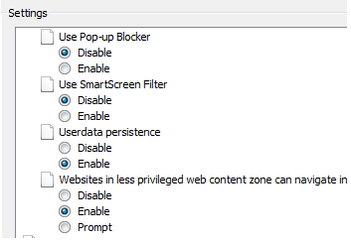

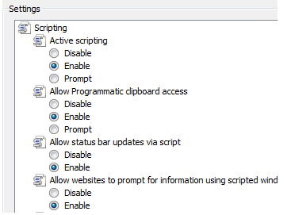

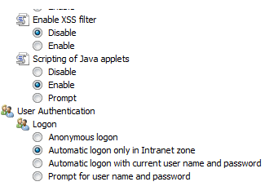

IE compatibility setting:




